Participate Actively. Talk Shop. Go Shopping! at Modellbahn in Mannheim from 10 to 12 March 2023

Innovations galore – FASZINATION MODELLBAHN makes it possible: the public will be able to experience this year’s model railway innovations live for the first time at the Maimarkthalle in Mannheim from the 10th through the 12th of March, 2023! The most up-to-date technologies, new digital features, cutting-edge equipment and great sound and lighting solutions will be on display. With its spectacular miniature layouts, world-class exhibitors, a highly diverse hands-on programme and lots of community feeling, the international trade fair for model railroading and accessories is a happening for the whole family that guarantees 100% enjoyment with model railways.

Technology fans, enthusiastic aficionados and passionate professionals will gain a comprehensive overview of current trends and new products in the model railroading industry at FASZINATION MODELLBAHN. In addition to countless exhibition layouts and their background stories, renowned manufacturers, associations and clubs will once again offer their visitors numerous opportunities this year for trying out products, playing, handicrafts and shopping. “Railway romantic” Hagen von Ortloff will also participate actively this year as a non-commercial exhibitor, and will be on hand to sign autographs for his fans. In the midst of these miniature worlds which chronicle both the past and the present, exhibitors from all over Germany, beautiful France, Italy, Austria, Poland, the Netherlands and the Czech Republic will offer modelling in all gauges, the latest technologies, model railway software, accessories and more covering all aspects of rolling stock. They’ll provide loads of inspiration for the visitors. FASZINATION MODELLBAHN offers families all kinds of opportunities for spending valuable time together and delving into the fascinating world of miniatures.
Model Railway Innovations for all Generations
As the market leader, Märklin has always accompanied model railway fans of all generations in the pursuit of their passion. The company’s repertoire ranges from finely rendered classics from all epochs of railroading history, all the way up to the powerful engines used in today’s train traffic. Märklin will once again present new products for all age groups at FASZINATION MODELLBAHN in 2023. Speaking of age: our happy birthday wishes go out to the Märklin Insider Club on their 30th anniversary! This milestone will be celebrated with a unique anniversary model: the heavy, class 44 freight-train steam locomotive is available for the first time with a tub tender, the mfx+ digital decoder and extensive sound functions.
Märklin “Start Up” provides a simple introduction to the educationally valuable hobby for small railway enthusiasts age six and up, for example with a (gold) high-power trio consisting of a freight train with steam locomotive, tipper wagon and freight wagon in colourful Haribo design. And even the smallest engine drivers as of 3 years old are sure to find their favourite theme world in the child-friendly “My World” product range, for example the “Car Transport” starter package featuring a powerful diesel locomotive with various sounds and lighting. Both product lines can be tested live at the large play area. Need professional advice? From technicians to seminar instructors, service personnel and layout builders, professionals from all disciplines will be available to interested visitors for discussions at Märklin’s booth.

Tillig has more than 140 new items in this year’s offerings, which are distinguished by high precision, accuracy and reliability. Digital drivers and newcomers can look forward to the newly developed version of the PIKO SmartController WLAN control system with colour display and WiFi connection at PIKO’s booth. Furthermore, the manufacturers will present numerous designs which can be admired and tested and are just waiting to be discovered by the model railway fans at FASZINATION MODELLBAHN 2023.

Layout Features at Their Best

Immerse yourself in other worlds, get creative, work with your hands, improve skills, shop and experience interesting historical events: all of this and more is made possible by the wonderful hobby of model railroading. By designing their own layouts, builders become the directors of their personal miniature worlds. The right accessories are necessary in order to create realistic layouts. Small-series manufacturers and accessory specialists will present an outstanding selection from over 40 product groups at FASZINATION MODELLBAHN, including rolling stock, analogue and digital components and figures, as well as nature and landscape scenery. Buildings, lighting, interiors and all kinds of decorations from different epochs can be purchased as well. As a market and innovation leader, Herpa offers especially authentic and sophisticated models of cars and trucks. In addition to a diverse product range including both modern and historical models, an exclusive trade fair model will also be on sale at Herpa’s booth: a Mercedes-Benz Sprinter 18 labelled “Faszination Modellbahn Mannheim 2023”. Trade fair visitors take home lots of new incentives, ideas and inspiration for their own projects. And they buy one or the other favourite new item that looks fabulous in their miniature worlds at home.

Into the Limelight: Eight Private Layouts in Competition

Visitors will experience a highlight of an exceptional sort at the unique private layout competition, which will be held jointly by the trade fair promoters and trade journal MIBA in keeping with the motto “From the Hobby Room in the Cellar Into the Limelight”. Eight private model railroading teams will compete with their imaginatively crafted railway layouts. They’re genuine artists, and visitors can take great pleasure in discovering the many subtleties of the layouts on display and chatting about the details with the proud layout owners. Whether experiencing a small grain silo loading facility in north-eastern USA on the “West Bend Grain” N gauge layout, observing the hustle and bustle of a small town in the provinces on an H0 gauge layout or marvelling at the H0e gauge shoe cabinet layout: they will all be judged by a qualified jury of experts at FASZINATION MODELLBAHN and will be duly celebrated during the award ceremony at the popular Model Railway Forum on Saturday at the trade fair.

MIBA will also celebrate its 75th anniversary this year. The “Weinheim-Tal” module group has launched a special project to mark the occasion: the “Weschnitzal-Überwald Project” (WÜP). The project will be presented step by step in trade journal MIBA from the January to the December 2023 issue, with a detailed description in the style of the legendary “Vogelsberger Westbahn” from 1998. The centrepiece is Mörlenbach Central Station, which will be presented to the public for the first time exclusively at FASZINATION MODELLBAHN Mannheim.

Always Up-to-Date with Clever Technology

The latest production technologies, including industrial 3D printing, are already standard in model railway manufacturing. Exhibitor DeskTop Locomotive Works is specialised in this field and will showcase its uniquely printed plastic kits for vehicle models and accessories at the trade fair. Clever Train Control will celebrate its premiere as an exhibitor at FASZINATION MODELLBAHN. They’ll bring along an intelligent, simple control system for locomotives using a smartphone app. A Wi-Fi connection, the CTC app and CTC modules are all you need to control locomotives, switches and signals. It’s simply super-duper!, as one fan commented on FASZINATION MODELLBAHN’s Facebook page.

The clubs and associations that provide professional tips on the issue of digital control and drive technology are of course also up to date. For example MEC Waiblingen, whose members are always happy to talk shop and offer advice and assistance to the interested public. Experts will also hold short, practical presentations dealing with complex topics at the Model Railway Forum, e.g. on lighting technology for model railway layouts. Cinema feeling with films of fascinating train trips from “Eisenbahn-Romantik” will round out the forum programme, which is free of charge for visitors.

Nostalgia with Proven Technology

Are you familiar with Bing? Once the world’s largest toy and tinware manufacturer, the company was kept going by Stephan Bing under the Trix brand after the Great Depression in the 1930s. Friends of the toy museum in Freinsheim/Pfalz, Germany (Bing Museum) will present a rare 1 gauge layout by Bing in Mannheim with steam engines and depot models as well as buildings and accessories from the years 1900 to 1928. Nostalgia and curio enthusiasts will get their money’s worth here. They’ll be awaited by lively railway operations as well as extensive information about the nearly forgotten brand. Those who are even more interested in fascinating and historically revolutionary technology can experience stationary steam-powered models on their pedestal displays and gain insights into their mechanical workings in the steam engine model-building area.

Mannheim in the Focus of the Model Railroading Community

Mannheim will advance to the centre of the model railroading community from the 10th through the 12th of March. And, precisely in this city, a new association has recently been founded that intends to make it possible for everyone to experience historical railway traffic in the Mannheim area. This goal will be implemented by means of cultural excursions on which families can explore the Rhine-Neckar region by rail, STEM projects for children and young people, and prevention work in schools. This young association which calls itself “Eisenbahnfreunde Mannheim e.V.” will introduce itself for the first time at FASZINATION MODELLBAHN and has some great offers in store: an H0 railway module, a Fischertechnik railway, a nostalgic miniature carousel from 1956, glitter tattoos for children and handicraft activities with the ICE. Collaboration and networking are on the agenda at the live exhibition, from which fans and families will benefit. For example, every child who visits the association’s booth will receive a free ticket to the Landau Reptilium.

Fun, Fun, Fun for Young and Old
FASZINATION MODELLBAHN inspires its visitors every time anew as a “hands-on trade fair”. This year too, kids will be able to discover this miniature hobby in a playful setting at a great variety of booths. At the Junior College Europe of the BDEF (German association of railroad enthusiasts), they’ll experience the fascination of model railroading at six stations and can even win attractive prizes with dioramas they’ve built themselves. Professionals will offer advice on the assembly of vehicle and building kits, the Vollmer stone art series and the right electronics to get “rolling stock” moving in the Viessmann-kibri and Vollmer handicrafts garden. Model railway manufacturers Märklin and PIKO will offer the smallest children a free play area for their first railroading experiences. “Attention All Handicrafters” is the motto at Aichner’s booth with handicrafts corner, where young and old alike can assemble trains and models of their choice with practical as well as theoretical guidance. Different types of wood and glue are used, as well as tools which are suitable for children. Not only does this improve one’s craftsmanship skills, it’s also a welcome alternative to the ubiquitous overload of digital media. Sparkling children’s eyes and satisfying teenager activities are assured at the 3-day adventure exhibition!

Detailed information and the online ticket shop for FASZINATION MODELLBAHN MANNHEIM, international trade fair for model railways and accessories, can be accessed at www.faszination-modellbahn.de.

2023 Exhibition Dates | 10 to 12 March 2023
Venue | Maimarkthalle Mannheim  Xaver-Fuhr-Str. 101  D-68163 Mannheim, Germany  www.maimarktgelaende-mannheim.de
Opening Hours | Friday through Sunday  from 9 a.m. to 5 p.m.
Online  Ticket Prices | Day pass, adults: €12.00 (admission for one person on one trade fair day)  Discount day pass: €10.00 (young people between 9 and 17 years, pupils, students, retirees or other entitled persons with ID on one trade fair day)  Family ticket: €30.00 (admission for 2 adults plus 2 verifiably own children age 9 to 17) – children up to 8 years of age are admitted free of charge  https://ticketshop.schall-messen.de/shop/tickets-fuer-die-faszination-modellbahn/

We look forward to your coverage and announcements. Appropriate image files can be found here: https://www.faszination-modellbahn.com/presse/

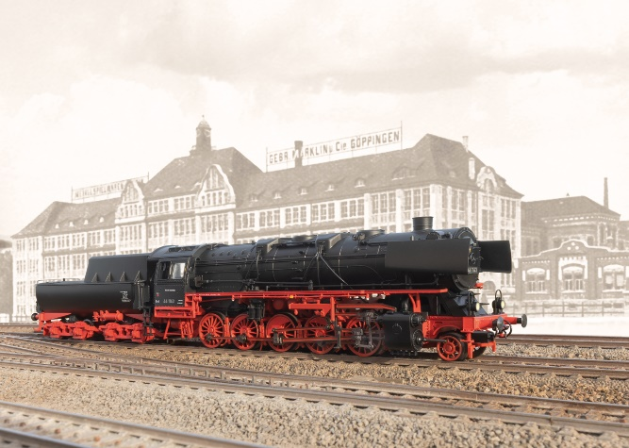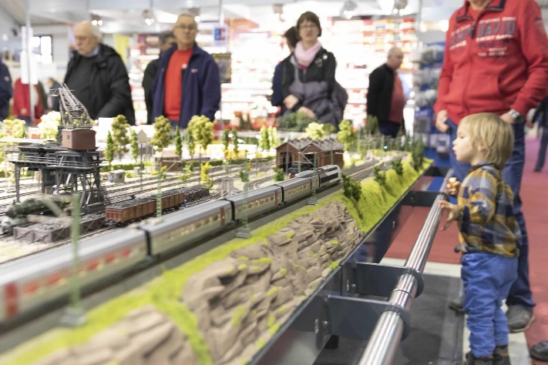
Märklin Insider Club Anniversary Model
BR 44 Steam Locomotive with Tub Tender

Contact:
Messe Sinsheim GmbH
Phone: +49 (0)7025 9206-100
Fax: +49 (0)7025 9206-88100
e-mail: presse@messe-sinsheim.de

Facebook YouTube Instagram

